Raymond Delgado

Professor Woo

CIS 5560

April 18, 2020

spark-submit PythonRegressionEvaluation.py

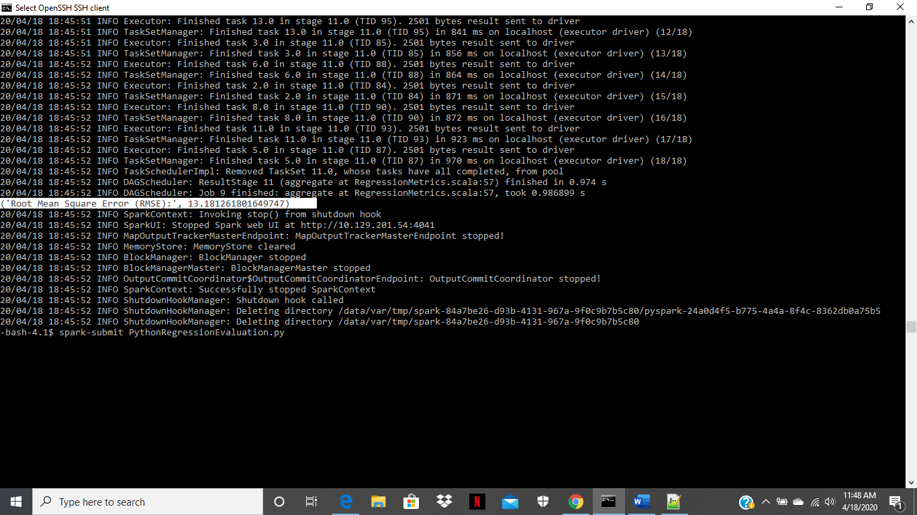

PythonRegressionParameterTuning.py

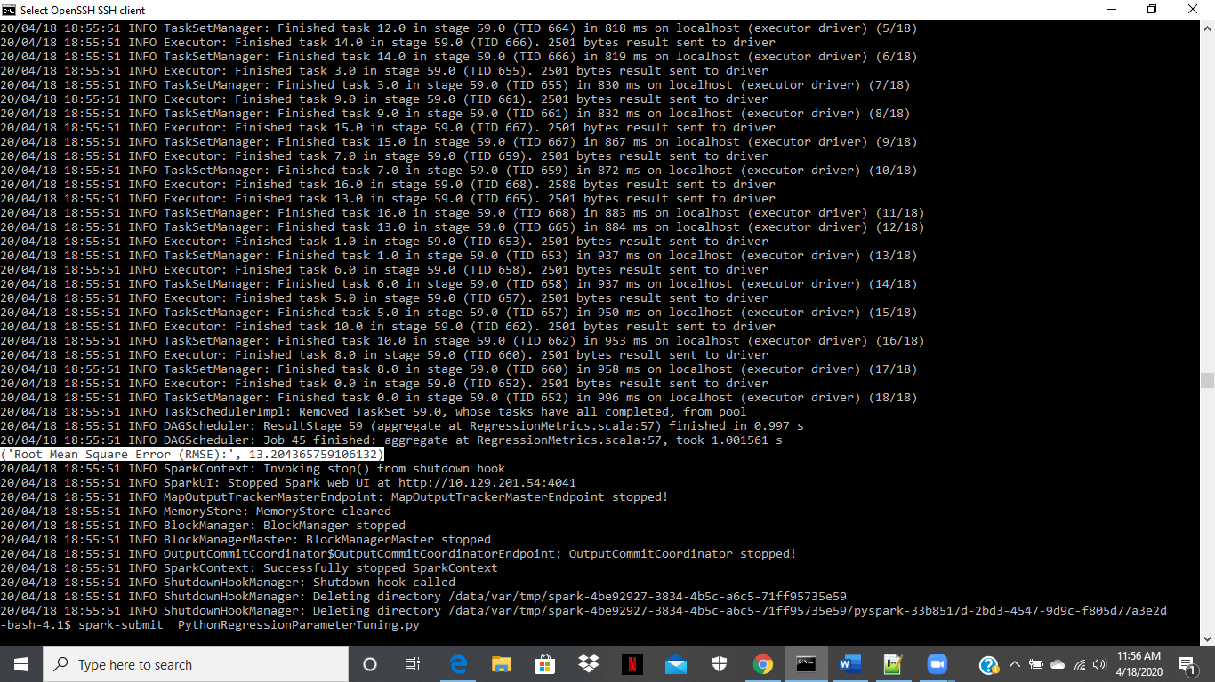

Pyspark (CrossValidationDB.py)

